HTML Text Formatting Elements

📘 Definition
# Source: AI Source: Provided by: [Data Path: Persons Table -> ID Column: 1, Name_En Column: Motasem Essam] -> From: [ChatGPT] on [5/6/2026]
HTML text formatting elements are used to format and style text inside a webpage.
They can:
- make text bold
- italic
- highlighted
- small
- deleted
- inserted
- subscript/superscript

🔤 Common HTML Text Formatting Elements
# Source: AI Source: Provided by: [Data Path: Persons Table -> ID Column: 1, Name_En Column: Motasem Essam] -> From: [ChatGPT] on [5/6/2026]
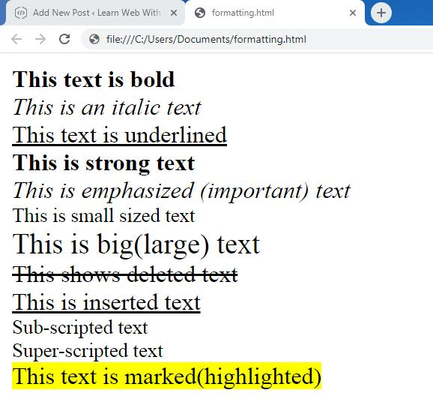
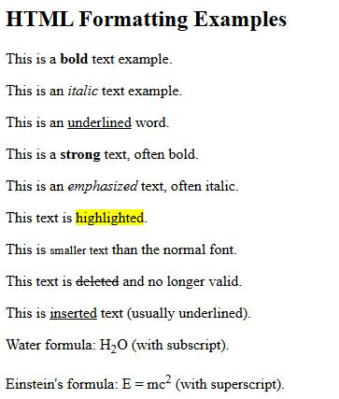
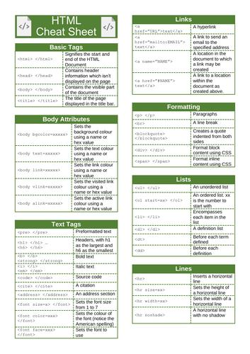

1. <b> — Bold Text
# Source: AI Source: Provided by: [Data Path: Persons Table -> ID Column: 1, Name_En Column: Motasem Essam] -> From: [ChatGPT] on [5/6/2026]
📖 Description
Displays text in bold without extra importance.
💻 Example:
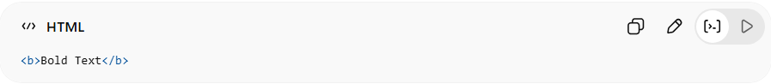
<b>Bold Text</b>

2. <strong> — Important Text
# Source: AI Source: Provided by: [Data Path: Persons Table -> ID Column: 1, Name_En Column: Motasem Essam] -> From: [ChatGPT] on [5/6/2026]
📖 Description
Displays important text (usually bold).
💻 Example:
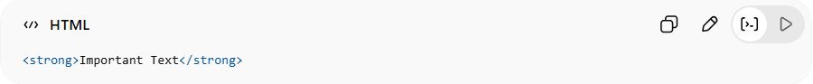
<strong>Important Text</strong>
👉 Has semantic meaning (importance)

3. <i> — Italic Text
# Source: AI Source: Provided by: [Data Path: Persons Table -> ID Column: 1, Name_En Column: Motasem Essam] -> From: [ChatGPT] on [5/6/2026]
📖 Description
Displays text in italic style.
💻 Example:
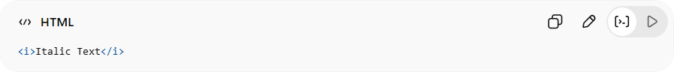
<i>Italic Text</i>

4. <em> — Emphasized Text
# Source: AI Source: Provided by: [Data Path: Persons Table -> ID Column: 1, Name_En Column: Motasem Essam] -> From: [ChatGPT] on [5/6/2026]
📖 Description
Emphasizes text (usually italic).
💻 Example:
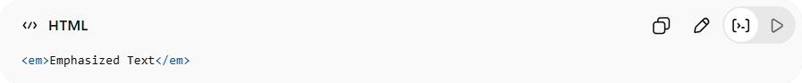
<em>Emphasized Text</em>
👉 Has semantic meaning (emphasis)

5. <mark> — Highlighted Text
# Source: AI Source: Provided by: [Data Path: Persons Table -> ID Column: 1, Name_En Column: Motasem Essam] -> From: [ChatGPT] on [5/6/2026]
📖 Description
Highlights text like a marker.
💻 Example:
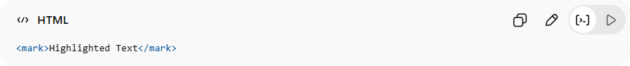
<mark>Highlighted Text</mark>

6. <small> — Smaller Text
# Source: AI Source: Provided by: [Data Path: Persons Table -> ID Column: 1, Name_En Column: Motasem Essam] -> From: [ChatGPT] on [5/6/2026]
📖 Description
Displays smaller-sized text.
💻 Example:
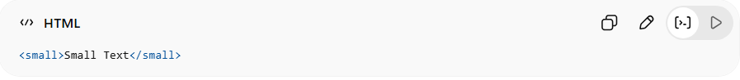
<small>Small Text</small>

7. <del> — Deleted Text
# Source: AI Source: Provided by: [Data Path: Persons Table -> ID Column: 1, Name_En Column: Motasem Essam] -> From: [ChatGPT] on [5/6/2026]
📖 Description
Shows deleted text with a line through it.
💻 Example:
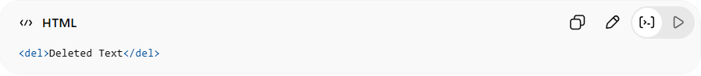
<del>Deleted Text</del>

8. <ins> — Inserted Text
# Source: AI Source: Provided by: [Data Path: Persons Table -> ID Column: 1, Name_En Column: Motasem Essam] -> From: [ChatGPT] on [5/6/2026]
📖 Description
Shows inserted text with underline.
💻 Example:
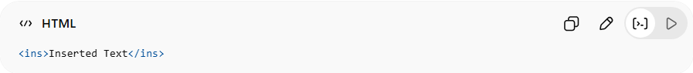
<ins>Inserted Text</ins>

9. <sub> — Subscript Text
# Source: AI Source: Provided by: [Data Path: Persons Table -> ID Column: 1, Name_En Column: Motasem Essam] -> From: [ChatGPT] on [5/6/2026]
📖 Description
Displays text slightly below normal text.
💻 Example:
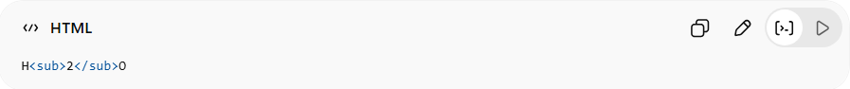
H<sub>2</sub>O
👉 Used in chemical formulas

10. <sup> — Superscript Text
# Source: AI Source: Provided by: [Data Path: Persons Table -> ID Column: 1, Name_En Column: Motasem Essam] -> From: [ChatGPT] on [5/6/2026]
📖 Description
Displays text slightly above normal text.
💻 Example:
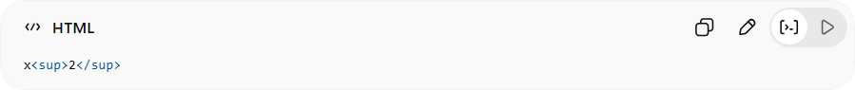
x<sup>2</sup>
👉 Used in math powers

⚖️ Semantic vs Visual Formatting
# Source: AI Source: Provided by: [Data Path: Persons Table -> ID Column: 1, Name_En Column: Motasem Essam] -> From: [ChatGPT] on [5/6/2026]
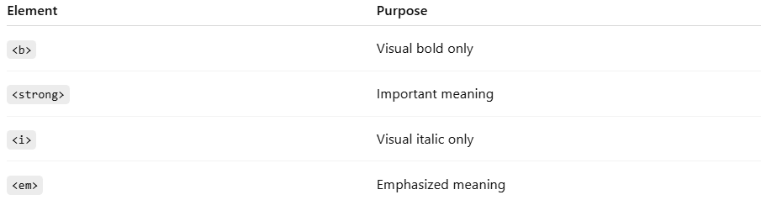
Element | Purpose
<b> | Visual bold only
<strong> | Important meaning
<i> | Visual italic only
<em> | Emphasized meaning

💻 Example

Full Example
# Source: AI Source: Provided by: [Data Path: Persons Table -> ID Column: 1, Name_En Column: Motasem Essam] -> From: [ChatGPT] on [5/6/2026]
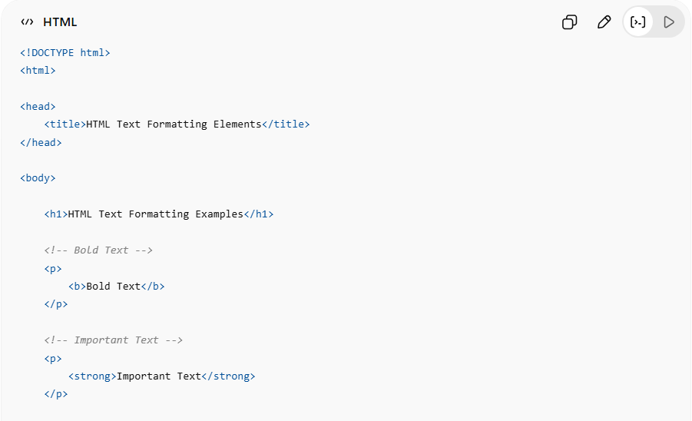
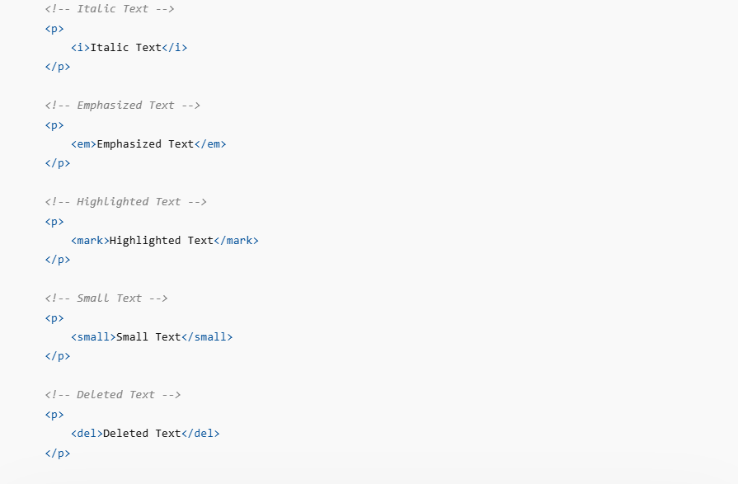
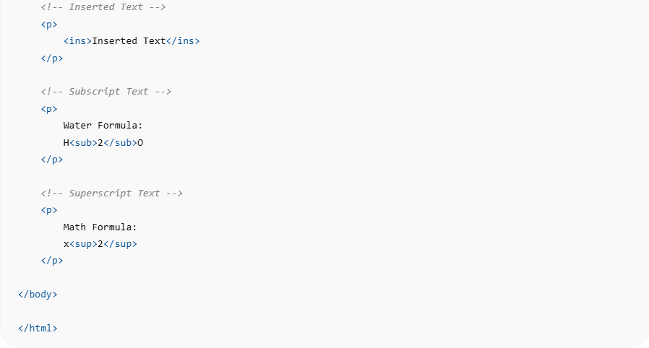
<!DOCTYPE html>
<html>

<head>
<title>HTML Text Formatting Elements</title>
</head>

<body>

<h1>HTML Text Formatting Examples</h1>

<!-- Bold Text -->
<p>
<b>Bold Text</b>
</p>

<!-- Important Text -->
<p>
<strong>Important Text</strong>
</p>

<!-- Italic Text -->
<p>
<i>Italic Text</i>
</p>

<!-- Emphasized Text -->
<p>
<em>Emphasized Text</em>
</p>

<!-- Highlighted Text -->
<p>
<mark>Highlighted Text</mark>
</p>

<!-- Small Text -->
<p>
<small>Small Text</small>
</p>

<!-- Deleted Text -->
<p>
<del>Deleted Text</del>
</p>

<!-- Inserted Text -->
<p>
<ins>Inserted Text</ins>
</p>

<!-- Subscript Text -->
<p>
Water Formula:
H<sub>2</sub>O
</p>

<!-- Superscript Text -->
<p>
Math Formula:
x<sup>2</sup>
</p>

</body>

</html>

Real Example
# Source: ScreenShot Source: Provided by: [Persons Table -> ID Column: 1, Name_En Column: Motasem Essam] -> Tool: [Automation Table -> ID Column: 16, Name_En Column: Screen Capture] -> From [Operating System: Windows] on [5/6/2026]
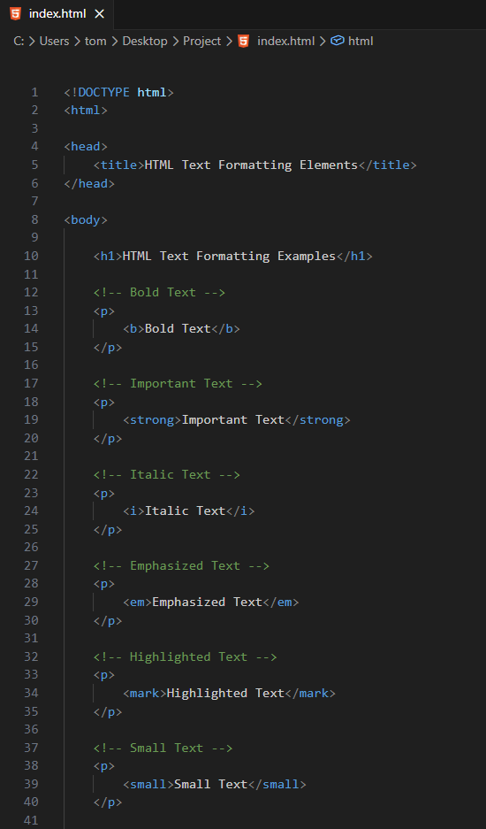
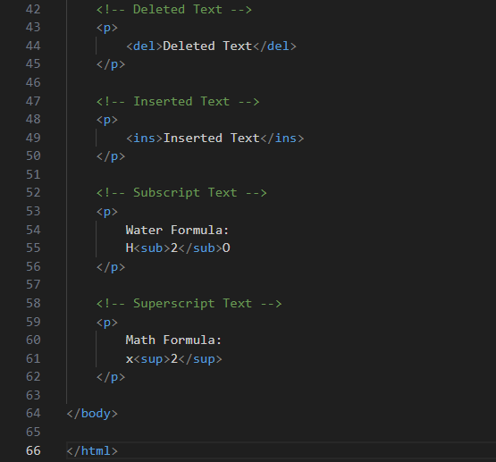
<!DOCTYPE html>
<html>

<head>
<title>HTML Text Formatting Elements</title>
</head>

<body>

<h1>HTML Text Formatting Examples</h1>

<!-- Bold Text -->
<p>
<b>Bold Text</b>
</p>

<!-- Important Text -->
<p>
<strong>Important Text</strong>
</p>

<!-- Italic Text -->
<p>
<i>Italic Text</i>
</p>

<!-- Emphasized Text -->
<p>
<em>Emphasized Text</em>
</p>

<!-- Highlighted Text -->
<p>
<mark>Highlighted Text</mark>
</p>

<!-- Small Text -->
<p>
<small>Small Text</small>
</p>

<!-- Deleted Text -->
<p>
<del>Deleted Text</del>
</p>

<!-- Inserted Text -->
<p>
<ins>Inserted Text</ins>
</p>

<!-- Subscript Text -->
<p>
Water Formula:
H<sub>2</sub>O
</p>

<!-- Superscript Text -->
<p>
Math Formula:
x<sup>2</sup>
</p>

</body>

</html>
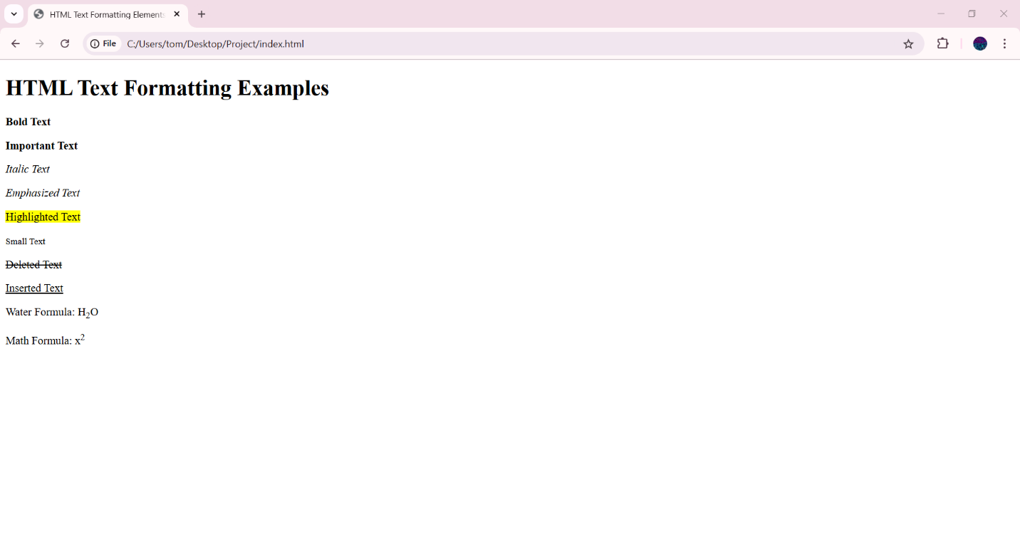

🚀 In short:
# Source: AI Source: Provided by: [Data Path: Persons Table -> ID Column: 1, Name_En Column: Motasem Essam] -> From: [ChatGPT] on [5/6/2026]
HTML text formatting elements are used to visually and semantically style text content in webpages.

